**Steps to reproduce defects**

**Defect:** Fatal Error seen when sending bad username at login

**Environment:** QA Challenge

**Priority: 1**

**Steps to reproduce:**

1. Set a bad user ie:testUser13
2. Add a bad password
3. Click login

**Current behavior:** A fatal error is seen onscreen

**Expected behavior:** User should be notified of the error and have another chance to login without refreshing the page

**Screen shot:** 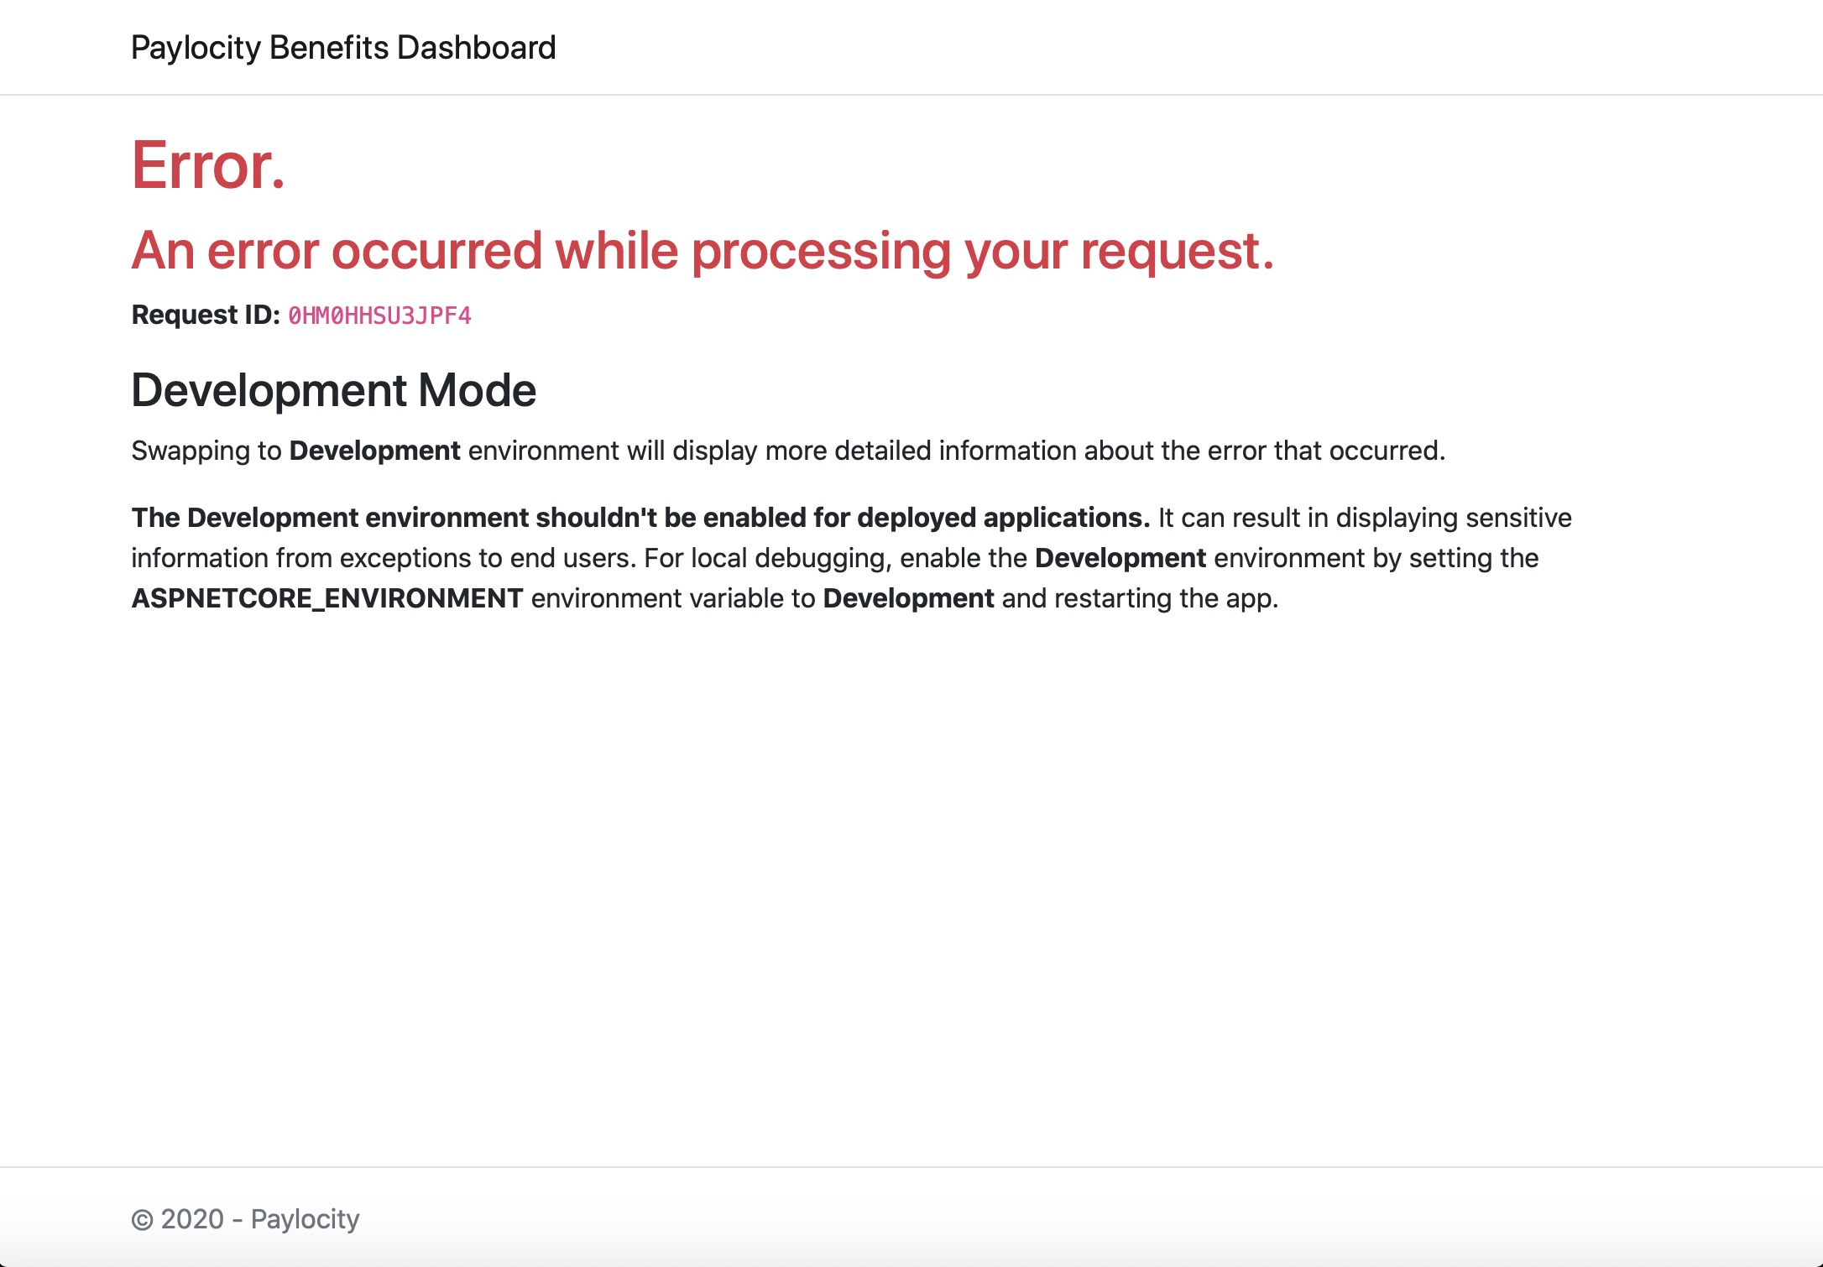

**Defect:** Header says Add Employee when it should say Update Employee

**Environment:** QA Challenge

**Priority: 3**

**Steps to reproduce:**

1. Log in to the Benefits administration application
2. Click the edit employee button
3. Notice the header title in the window

**Current behavior:** Header says Add Employee

**Expected behavior:** Header title should say Update Employee

**Screen shot:**

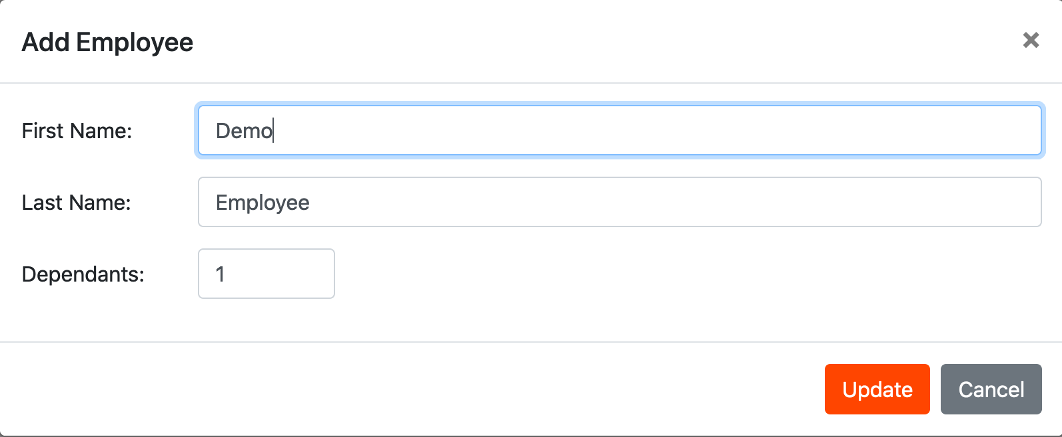

**Defect:** Refreshing session shows empty table

**Environment:** QA Challenge

**Priority: 3**

**Steps to reproduce:**

1. Log in to the Benefits administration application
2. Click the refresh button for the browser

**Current behavior:** Table is empty

**Expected behavior:** User should not see a empty table

**Screen shot:**

